



Report Title: Habit Tracker: A Java-Based Web Application Using Spring Boot
SOUTHEAST UNIVERSITY

Submitted By
Name: MD. Siam Sheikh
ID: 2023100000033
BATCH: 64
Course Tittle: Advanced Java
Code: CSE352.2
Section: 01

Submitted To
Name: [FIZA] Nabiha Fiza

Occupation: Lecturer, Department of CSE

Date Of Submission: 29-09-2026

1. Introduction
The Habit Tracker is a web-based application developed using Java and the Spring Boot framework to help users create, organize, and monitor their daily habits. The system provides a simple interface where users can manage their habits and categories through different web pages. The project uses Thymeleaf for the front end, Spring Data JPA for database operations, and an H2 database for data storage. The main objective of the project is to demonstrate how a Java-based web application can connect its user interface, backend logic, and database into one functional system.
2. Required Tools
The Habit Tracker was developed using several tools and technologies for the frontend, backend, database, and project management.
2.1 Main Required Tools
- Java JDK 25
- Spring Boot
- Spring Web
- Spring Data JPA
- Thymeleaf
- HTML
- CSS
- H2 Database
- Maven
2.2 Backend Technologies
- Java
- Spring Boot
- Spring MVC
- Spring Data JPA

2.3 Database
- H2 Database
- H2 Database Console
2.4 Frontend Technologies
- HTML5
- CSS
- Thymeleaf Template Engine
2.5 Project Dependencies
The project also uses several Maven dependencies to provide the required functionality.
Important dependencies include:
- Spring Boot Starter Web
- Spring Boot Starter Thymeleaf
- Spring Boot Starter Data JPA
- H2 Database
3. Project Description
The Description section explains the main pages and functionality of the Habit Tracker application. Screenshots of the working application should be inserted for each important page.
User
↓
Registration
↓
Login
↓
Dashboard
↓
┌───────────────┬────────────────┐
↓ ↓ ↓
Habits Categories Statistics
↓ ↓
Add/Edit/Delete Add/Delete
↓
Mark Complete
3.1 Registration Page
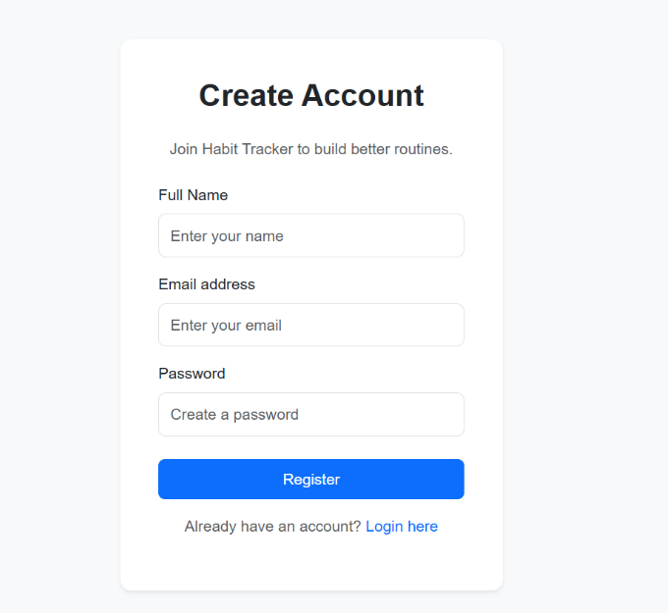
The registration page allows a new user to create an account.
The user provides the required information, such as:
- Name
- Username/email
- Password
After submitting the registration form, the user's information is stored in the H2 database.
Figure 1: User Registration Page
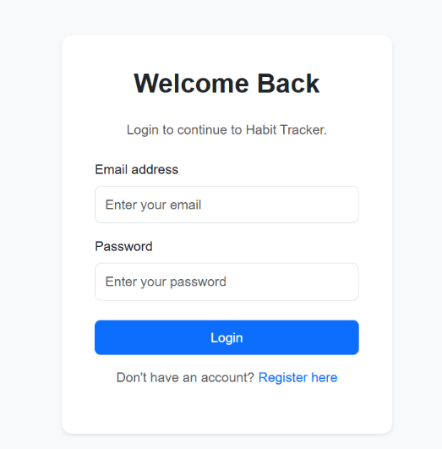
3.2 Login Page
The login page allows registered users to access the application.
The user enters their login credentials. The system checks the provided information against the registered user information stored in the H2 database.
Figure 2: User Login Page

If the credentials are valid, the user is logged in and redirected to the dashboard.
Screenshot
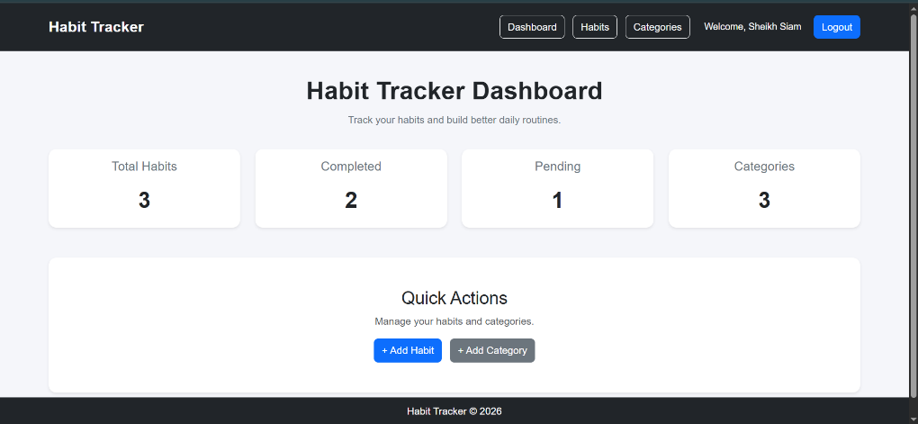
3.3 Home Page
Description:
The Home Page is the main entry point of the Habit Tracker application. It provides users with access to the main functionality of the system. From this
Figure 3: Habit Tracker Home Page
page, users can navigate through the available habit-related features.
The page is designed with a simple and user-friendly interface so that users can easily understand the purpose of the application and access the habit management features.
3.4 Habit Management Page
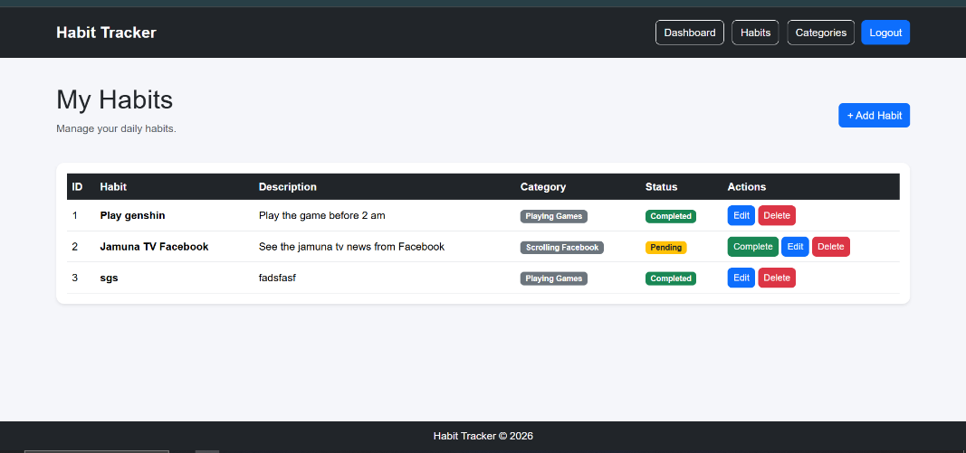
Description:
The Habit Management section allows users to view and manage their habits. Each habit represents an activity that the user wants to
Figure 4: Habit Management Page
perform regularly. The system retrieves the stored habit information from the database and displays it through the web interface. Users can use this section to organize their daily activities and keep track of their habits.
The page demonstrates the connection between the frontend and backend because the displayed information is retrieved from the database through the Spring Boot application.
3.5 Add Habit Page
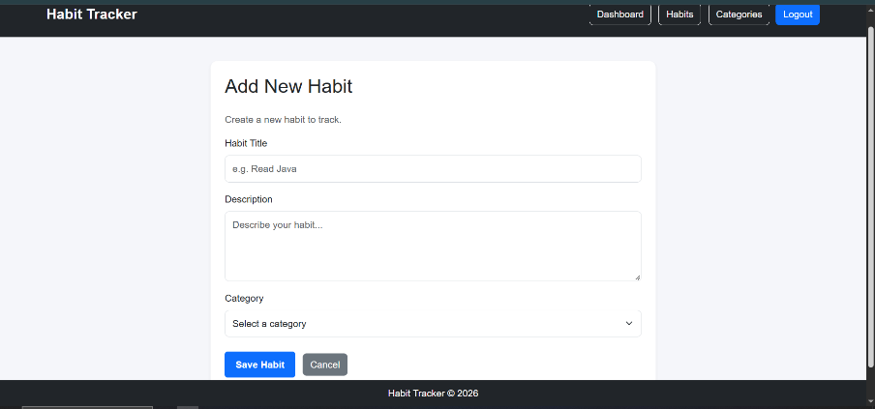
Description:
The Add Habit feature allows users to create a new habit. The user provides the required information through an HTML form. When the form is submitted, the request is processed by the Spring Boot controller. Figure 5: Add Habit Page
The information is then passed through the application's backend layers and stored in the H2 database using Spring Data JPA.
This feature demonstrates how user input from the frontend can be processed and stored in a database.
3.6 Category Management
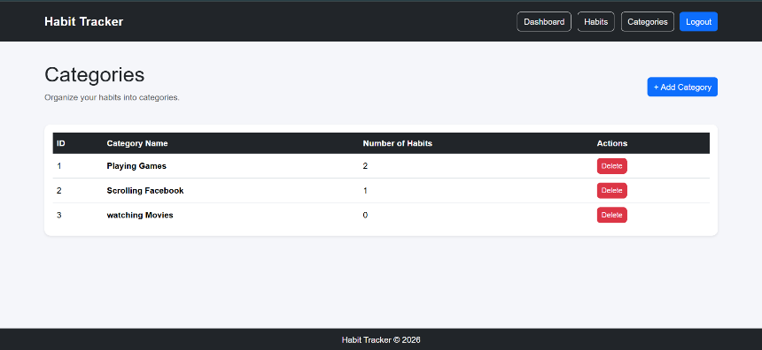
Description:
The Category Management feature allows habits to be organized into different categories. Categories help users group related habits and make the habit-tracking system easier to manage. The project contains Figure 6: Category Management Page
dedicated backend components for category management, including a category controller, service, and repository. These components communicate with the database to store and retrieve category information.
3.7 Add Category
Description:
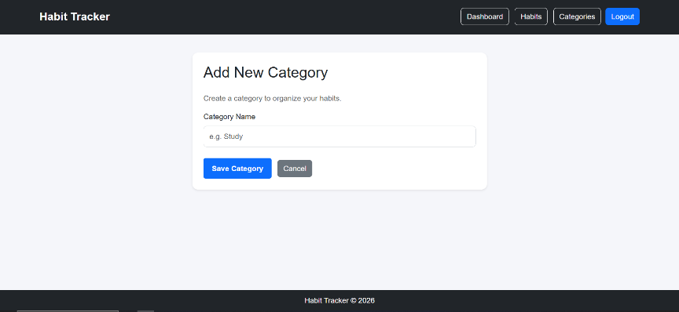
The Add Category page provides a simple form for creating a new category. The user enters the category name and submits the form.
The category is then stored in the H2 database and becomes available when creating or editing habits. Figure 7: Add Category Page
3.8 H2 Database Console
Description:
The H2 Database Console is used to inspect and manage the database during development. It allows the developer to view tables and verify whether information submitted through the application is being stored correctly.
# H2 Database
spring.datasource.url=jdbc:h2:file:./data/habitdb
spring.datasource.driver-class-name=org.h2.Driver
spring.datasource.username=sa
spring.datasource.password=

4. Back End
The backend of the Habit Tracker is developed using Java and Spring Boot. The backend is responsible for processing user requests, implementing application logic, communicating with the database, and returning the appropriate information to the frontend.
The application follows a layered architecture consisting of controllers, services, repositories, and model/entity classes.

4.1 Backend Architecture
The basic backend structure of the application is:
Spring Boot Application
↓
Controller
↓
Service
↓
Repository
↓
H2 Database
Each layer has a specific responsibility.
Controller
The controller receives HTTP requests from the user's browser and determines which operation needs to be performed.
For example, the Home Controller manages requests related to the application's main pages.
Service
The service layer contains the application's business logic. It acts as an intermediate layer between the controllers and repositories.
For example, category-related operations can be handled through a CategoryService.
Repository
The repository layer is responsible for communicating with the database. Spring Data JPA provides repository functionality that allows database operations to be performed without writing large amounts of SQL code manually.
For example, a category repository can be used to save and retrieve category information.
Model
The model/entity classes represent the data stored in the database. They define the attributes of the application's objects and their relationship with database tables.
4.2 H2 Database
The application uses the H2 Database as its database system.
The project uses an in-memory H2 database configuration similar to:
spring.datasource.url=jdbc:h2:mem:habitdb
spring.datasource.driver-class-name=org.h2.Driver
JPA is used to create and manage the database tables based on the Java entity classes.
4.3 Thymeleaf
Thymeleaf is used as the template engine for the application's frontend.
The general communication process is:
Browser
↓
Thymeleaf HTML Page
↓
Spring Boot Controller
↓
Service Layer
↓
Repository
↓
H2 Database
When a user submits a form, the request is received by the controller. The controller communicates with the service and repository layers, and the required information is stored or retrieved from the database.
The resulting data is then returned to the Thymeleaf page and displayed to the user.
4.4 Backend Screenshot
Description
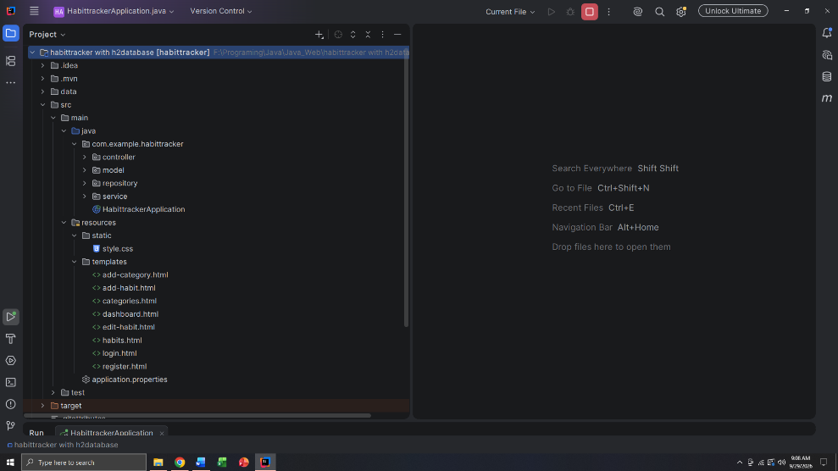
The project is organized into different packages according to their responsibilities. The structure separates the controller, service, repository, and model components.
This organization makes the application easier to understand, maintain, debug, and extend. Figure 8: Backend
A simplified structure is:
src
└── main
├── java
│ └── com.example.habittracker
│ ├── controller
│ ├── model
│ ├── repository
│ └── service
└── resources
├── templates
├── static
│ └── css
└── application.properties
4.5 Application Configuration
The application configuration is stored in the application.properties file.
Important configuration includes the H2 database connection, JPA configuration, and H2 console configuration.
The H2 console is enabled so that the developer can inspect the database during development.
5. Conclusion
Developing the Habit Tracker project helped me understand how a complete Java web application is developed by connecting the frontend, backend, and database together. Through this project, I learned how to use Spring Boot to create a web application and how controllers, services, repositories, and model classes work together.
One of the important things I experienced during development was dealing with configuration and application startup problems. Understanding the relationship between the project dependencies, Java version, Spring Boot configuration, database configuration, and application structure was initially challenging. Debugging these issues helped me understand that a backend application requires all of its components to be correctly connected.
Overall, this project gave me practical experience in Java, Spring Boot, Spring MVC, Thymeleaf, Spring Data JPA, Hibernate, HTML, CSS, and H2 Database. It also improved my understanding of layered application architecture and the development process of a database-driven web application.

